IBM ASSIGNMENT- 1

TEAM ID :

NAME: REFANA.N ROLL NO: 963019104006

make a smart home with sensors using arduino uno

# CIRCUIT LAYOUT:

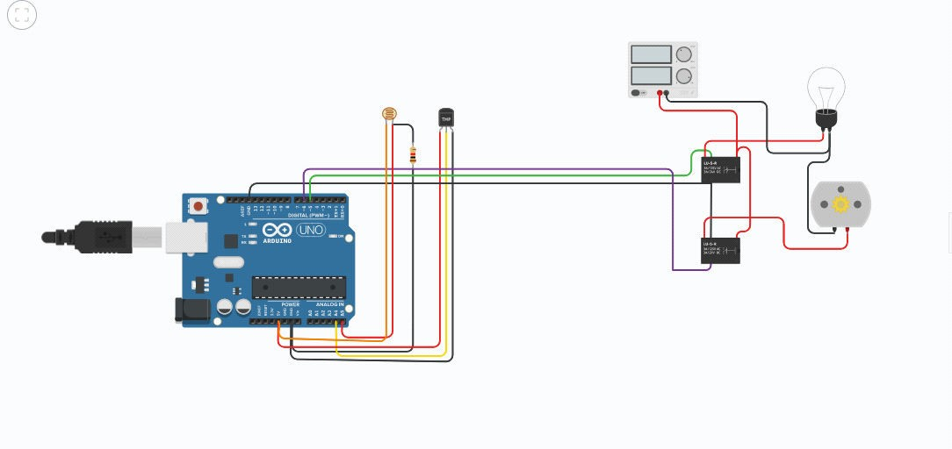

CODE:

float y,z,temp; void setup()

{

pinMode(5, OUTPUT); pinMode(6, OUTPUT); pinMode(A5, INPUT); pinMode(A4, INPUT);

Serial.begin(9600);

}

void loop()

{

y= analogRead(A5); z= analogRead(A4);

Serial.prfloat y,z,temp; void setup()

{

pinMode(5, OUTPUT); pinMode(6, OUTPUT); pinMode(A5, INPUT); pinMode(A4, INPUT);

Serial.begin(9600);

}

void loop()

{

y= analogRead(A5); z= analogRead(A4); Serial.println(y); Serial.println(z);

temp = (double)z / 1024; temp = temp * 5;

temp = temp - 0.5;

temp = temp * 100;

{

if ((y<550)&&(temp>30))

{

digitalWrite(5, HIGH); digitalWrite(6, HIGH);

}

else if((y<550)&&(temp<30))

{

digitalWrite(5, HIGH); digitalWrite(6, LOW);

}

else if((y>550)&&(temp>30))

{

digitalWrite(5, LOW); digitalWrite(6, HIGH);

}

else if((y>550)&&(temp<30))

{

digitalWrite(5, LOW); digitalWrite(6, LOW);

}

}

}

intln(y);

Serial.println(z);

temp = (double)z / 1024; temp = temp * 5;

temp = temp - 0.5; temp = temp * 100;

{

if ((y<550)&&(temp>30))

{

digitalWrite(5, HIGH); digitalWrite(6, HIGH);

}

else if((y<550)&&(temp<30))

{

digitalWrite(5, HIGH); digitalWrite(6, LOW);

}

else if((y>550)&&(temp>30))

{

digitalWrite(5, LOW); digitalWrite(6, HIGH);

}

else if((y>550)&&(temp<30))

{

digitalWrite(5, LOW); digitalWrite(6, LOW);

}

}

}

# OUTPUT:

